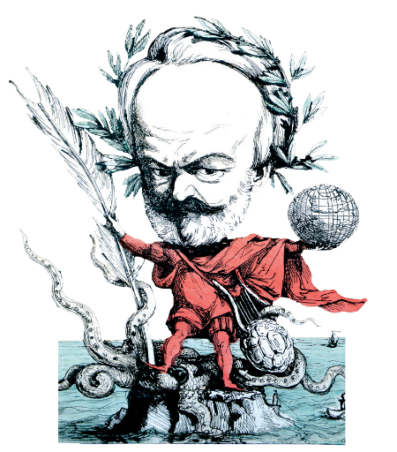
Victor Hugo In Guernsey Festiv Programme

al

2nd to 10th April 2016

There is to be a Festival in April 2016 to commemorate
the 150th Anniversary of the publication of Toilers of the Sea, a world famous novel written in Guernsey by
Victor Hugo during his exile.

Exhibition of Cartoons (Caricatures) of Victor Hugo during his exile.
24 Enlargements in the Market Inner Street for 2 weeks from 2 April.
Originals at the Archive Centre, St. Barnabas for 1 week.

Seminar on the life of Hugo in exile.
Four acknowledged world experts on Hugo speaking in day-long seminar with Q&A.
Saturday 2nd April at Les Cotils.

Victor Hugo Concert
The programme is still being formulated but will feature International Canadian pianist, singer and songwriter, Alain Lecompte.
Saturday 2nd April at St. James.

The Art of Hugo
Lecture by Martin Morgan on Victor Hugo’s artistic work. Martin was the instigator of the Folio publication of Toilers.
Date & location to follow.

The Soul of the Sea – Video Performance. Continuous presentation of the previous performance at The Town Church of Magnus Buchanan’s tribute to ‘Toilers’ with paintings by Charlie, his wife.
Date & location to follow.

The Soul of the Sea – Live Performance.
A 40 minute performance by local actors with Charlie’s paintings projected at the same time.
Includes a talk by Gregory on the relationship of
Travailleurs to local events at the time.

Hugo’s Banquet
A Six course lunch for 200, replicating a dinner given by Hugo for friends at Hauteville House. It will include live performances of music and drama.
Sunday 3rd April in The Market Inner Street.

In the Footsteps of Hugo.
A full programme of guided walks and tours of St. Peter Port and Guernsey by Accredited Guides. Centred on the Festival desk.

Toilers’ Shop Competition.
A six-week in-shop (24 shops) competition for local children and visitors.

Festival educational programme
The Festival has an extensive programme to stimulate interest in Hugo in schools and youth organisations. Competitions for writing, poetry, photography, dance and drama are being organised for all age groups. The Festival also hopes to provide storytellers.
The winners in all clases will be exhibited in St. Peter Port and dance and drama winners will be performed during the Banquet.

Victor Hugo’s famous feeding the poor
The Festival hopes to recreate Hugo’s famous meals for the poor in Primary Schools.

Hugo’s Guernsey
An exhibition of photographs and objects associated with the period of Hugo’s exile at The Priaulx Library.

Toilers of the Sea
An exhibit of Hugo memorabilia and photographs from the Islands Museum resources.
At The Candie Museum.

The Festival is being organised by: ‘The Victor Hugo in Guernsey Society’ The Society is a registered charity CH507.
Bankers: HSBC.

Website: victorhugoinguernsey.gg
Festival Director: Roy Bisson:
T: 07781 100 296, E: Roy@Bisson.com

Festival Chairman: Gregory Stevens Cox:
T: 722920, E: toucan.guernsey@gmail.com Issue: 13.09.2015

